Assignment 8: In a Jenkins master–slave architecture with one master and two slave nodes, deploy the index.html file from Repo1 to the master, deploy the index.html file from Repo2 to Slave 1, and deploy the index.html file from Repo3 to Slave 2.
Master slave Architecture-
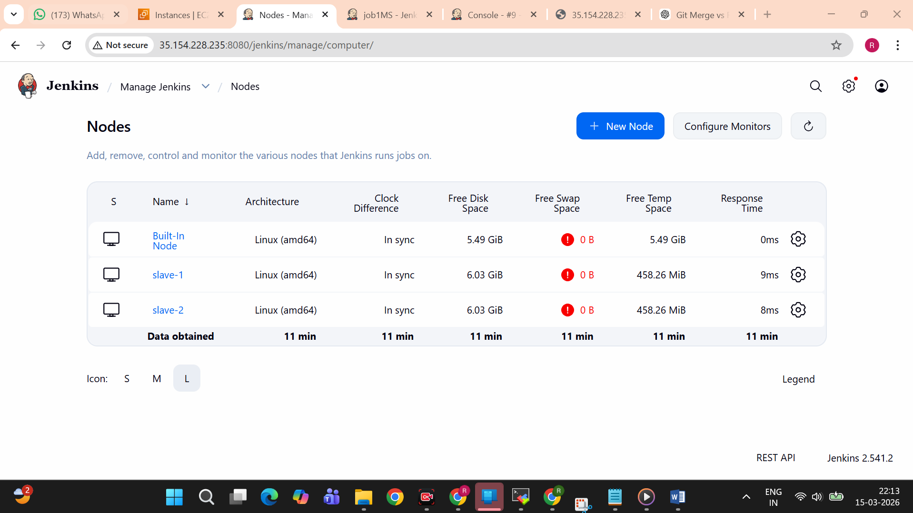
Job running on Master-
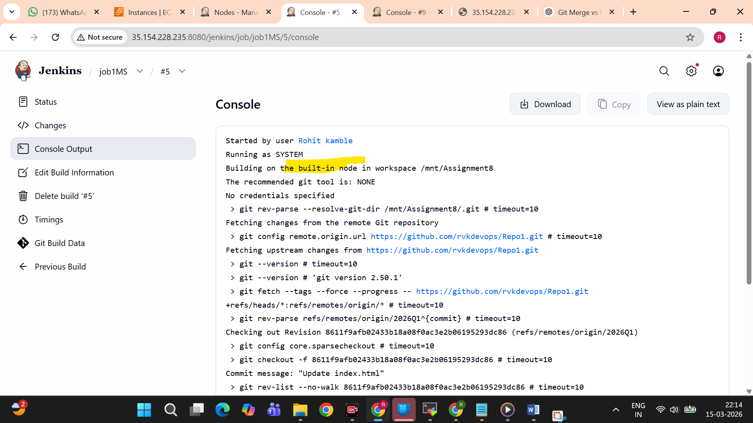
Deployed on Master-
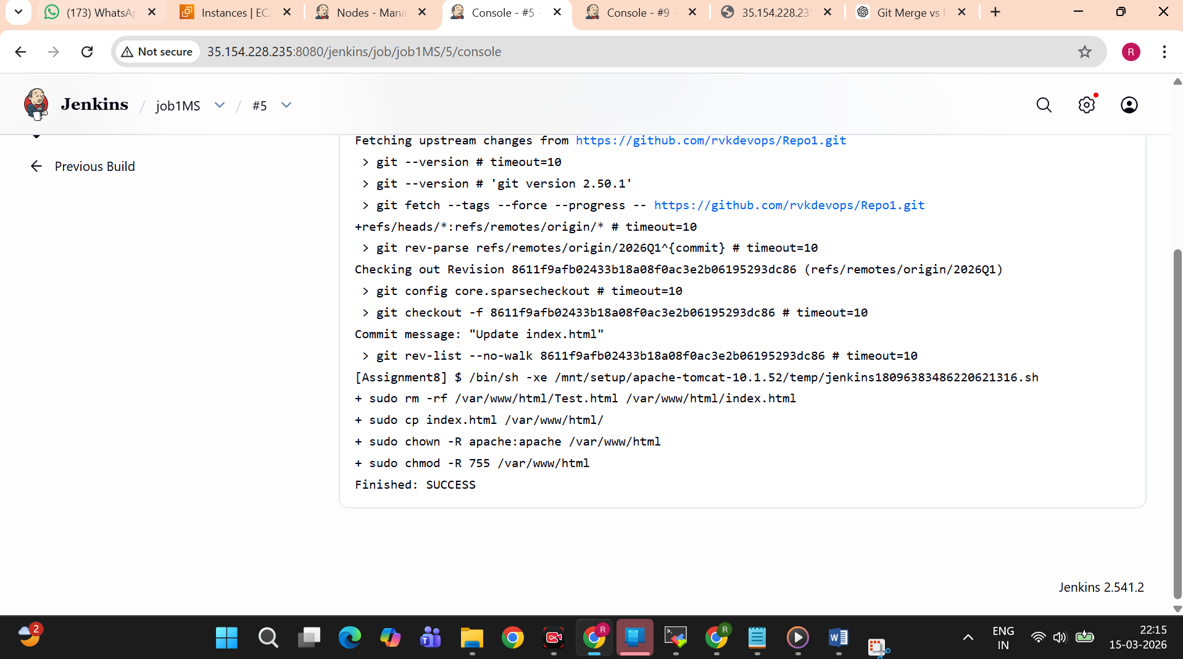

Accessed using Master IP address-
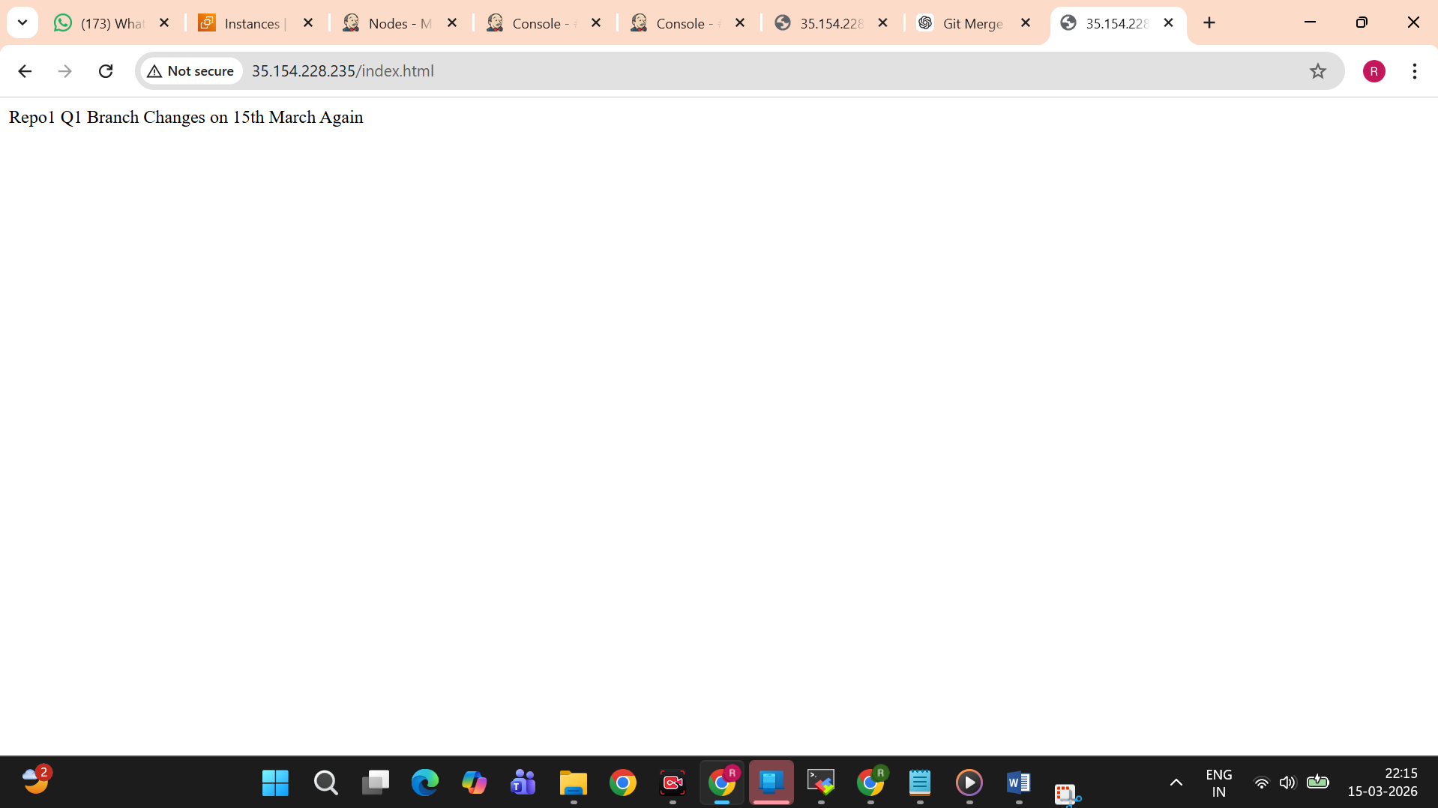
Job2- Running on slave-1
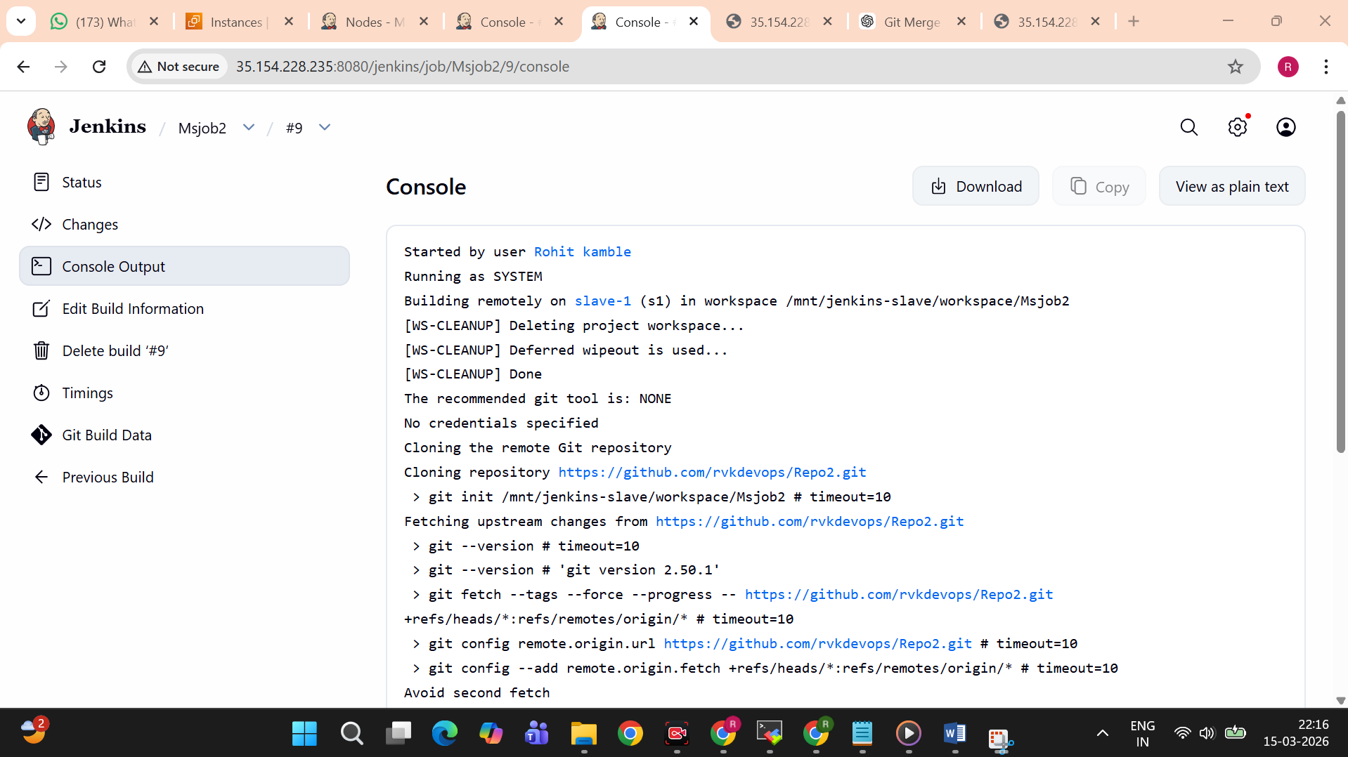
Deployed on slave 1-
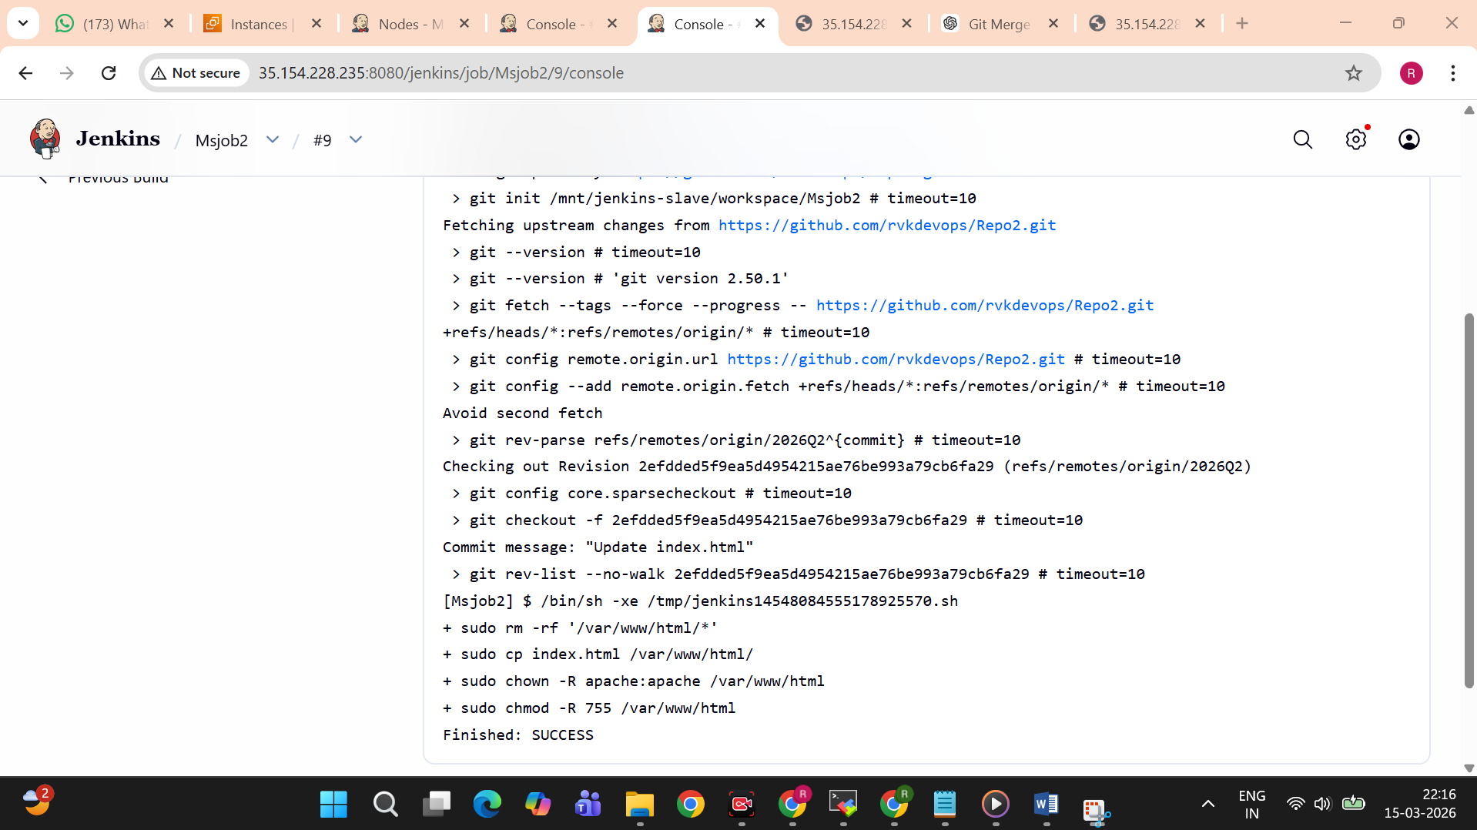
accessed using slave 2 url-
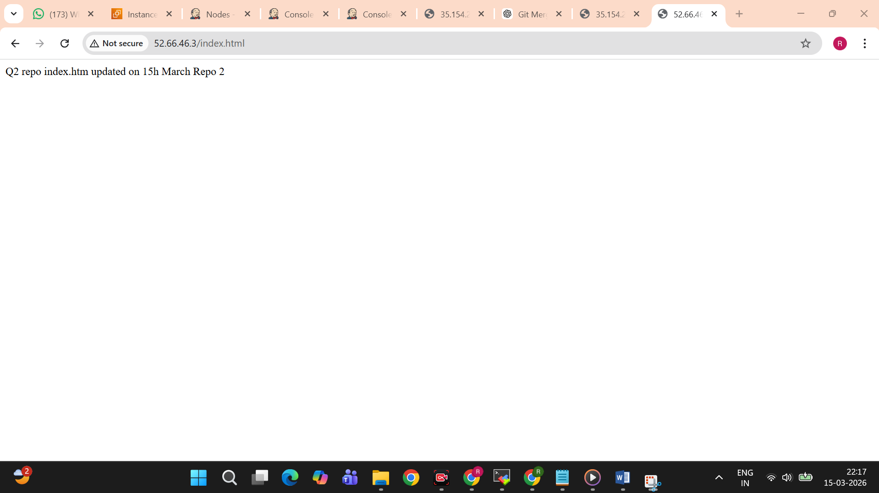
Job 3 -
Running on slave 2
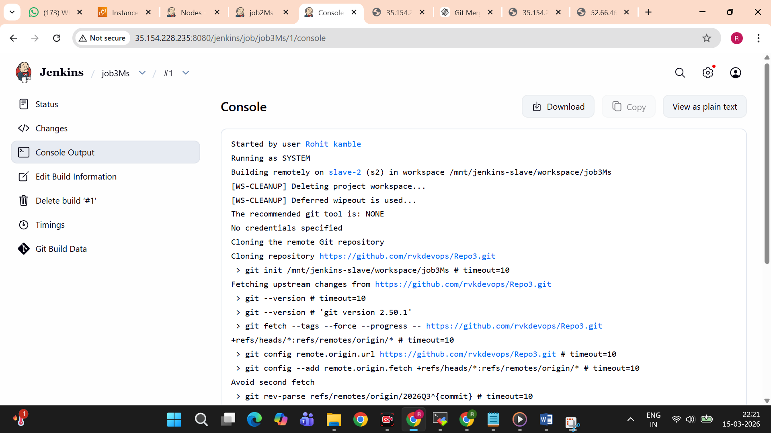
Deployed successfully-
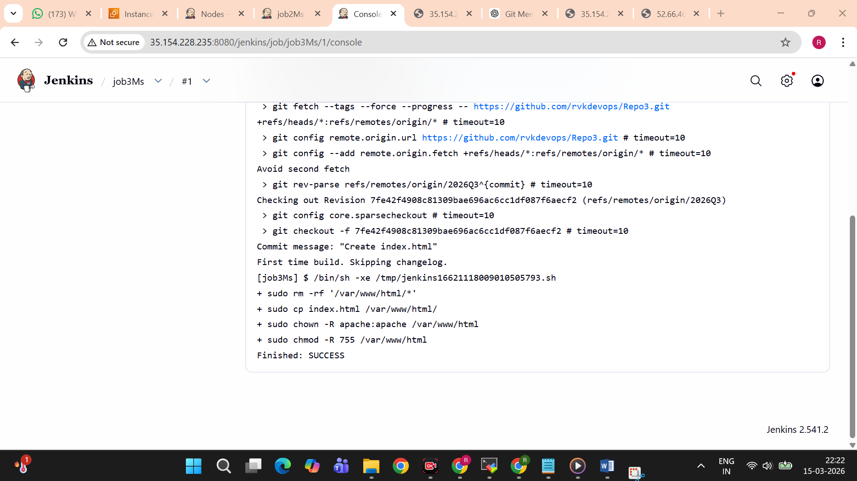

Accessed using IP of slave 2-
